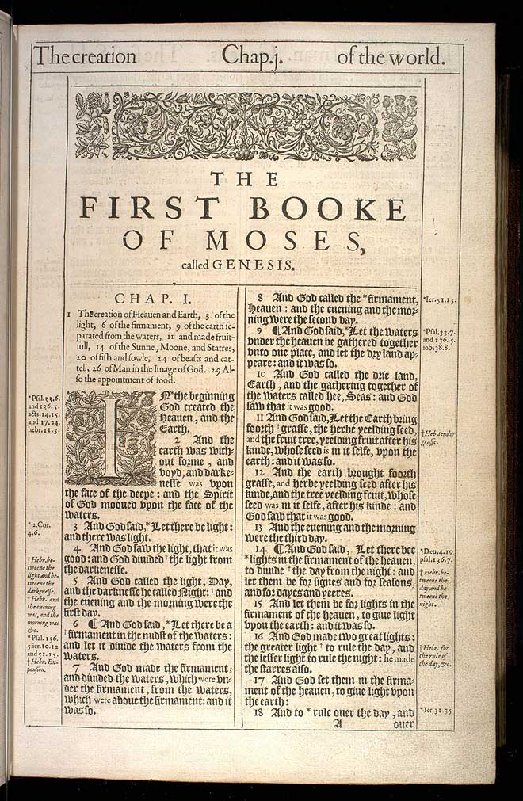

Orthodox Study Bible (Thomas Nelson, 2008); Ancient Faith Bible edition of the OSB (Ancient Faith Publishing, 2019); New King James Text but follows Septuagint

The Old Testament According to the Seventy (Pentateuch), trans. Michael Asser, Lulu

Christian Standard Bible, Ancient Faith Study Bible (Holman, 2019)

---

Orthodox Dogmatic Theology, by Protopresbyter Michael Pomazansky (St. Herman of Alaska Brotherhood, 2021)

Genesis, Creation, and Early Man: The Orthodox Christian Vision by Fr. Seraphim Rose, Second Edition, ed. Abbot Damascene (Christiansen) (St. Herman of Alaska Brotherhood, 2011)

---

Septuaginta: A Reader’s Edition (2 vols), ed. Lanier and Ross (Hendrickson, 2018)

https://www.blueletterbible.org/ Search engine for LXX (Septuagint) verses and vocabulary

---

Chronography— In traditional Orthodox years, this is Year 7530 (Year 7531 on Sept. 1/14)

Decline and Fall of Byzantium to the Ottoman Turks by Doukas, trans. Harry J. Magoulias (Wayne State University, 1975), from the late 15th c.

The Chronography of George Synkellos, trans. Adler and Tuffin (Oxford, 2002), c. 810

Sacred Annals by GE Smith (1847, reprints available)

The Annals of the World by James Ussher (1658, reprints available)

